Agenda
May 15, 2023, Monday- 7 PM

Old Items:
- Mission- once sentence – 5 minutes (Need an Owner of this, Susan?)
  - Spokes & Wheel model
  - 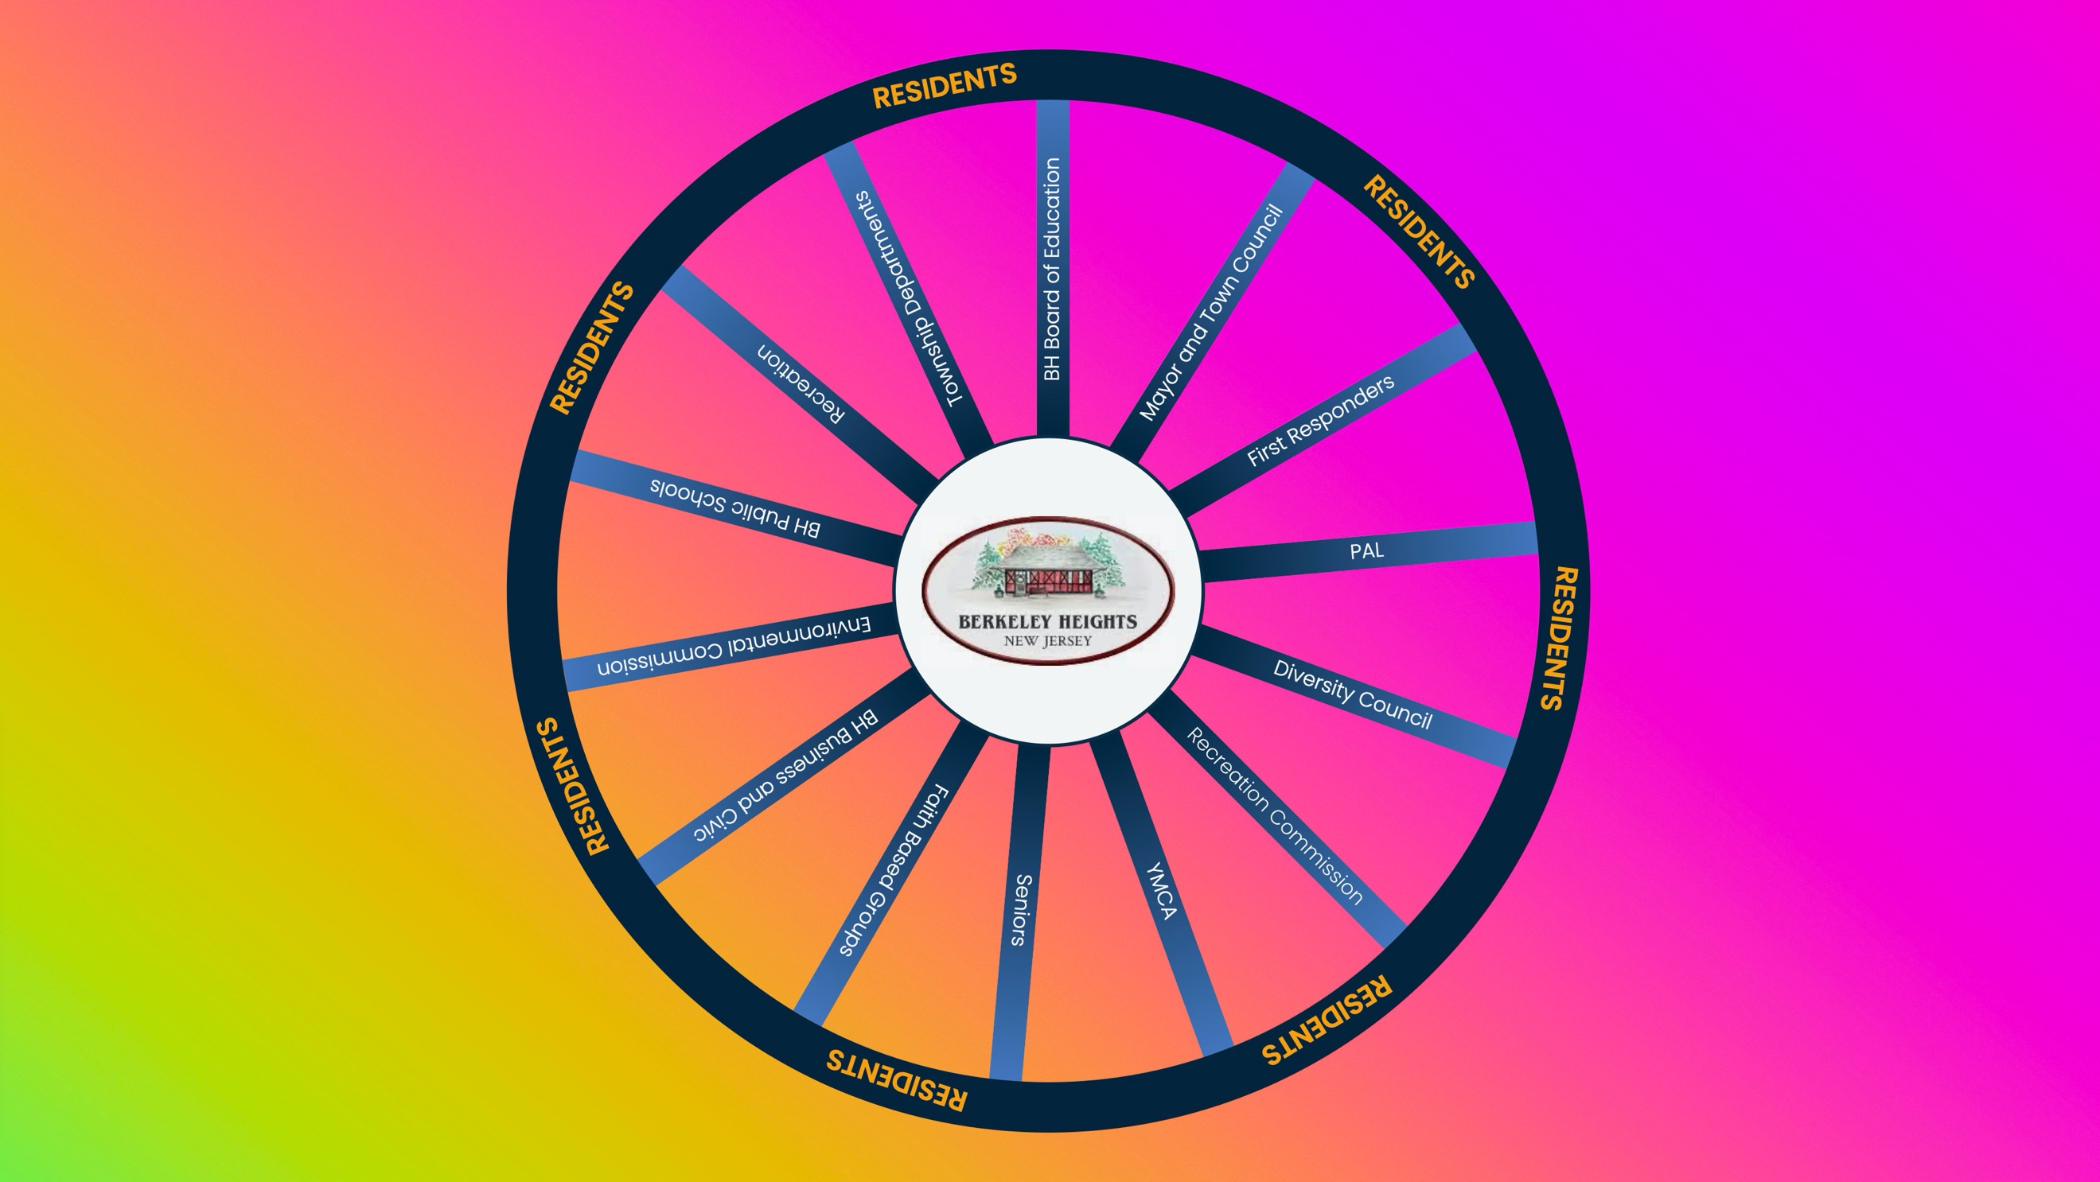
  - Assign members to “spokes”

- The Human Library – 5 minutes (Do we need an owner of this Pilar)
  - “Books”
    - Senior, Veteran, Religious backgrounds, Ethnic backgrounds, Different Abilities, Sexual Orientation (Timing and launch date?)

- Flag Raisings – 10 minutes (Do we need an owner of this Pilar)
  - May - AAPI Month, Military Appreciation Month
  - June - Pride Month, Portugal Flag Raising Day (June 2)
  - Mid Sept – mid Oct. - Hispanic Heritage
  - October - Italian Heritage Month (or Mt Carmel Festival)
  - February 2024 - Black History Month
  - March 2024 - Women’s History Month
  - 2024 - Ukraine (Township purchased flag)

- Celebrations – 10 Minutes (Do we need an owner of this Pilar)
  - Welcome to Town (Updated Information Packet / Basket)
  - “Celebrate Your Neighbor with an Act of Kindness” Month (Need to Select a Month, should it be June or September)
    - New Idea – “Chalk the Walk” from Washington Elementary #beknid
  - Ways to Celebrate our Community- Student contest, Google form
  - Spot Light series on remarkable residents

- BHPD (5 minutes)
  - Part of the expanded pilot program Arrive Together in Union County.
- Ordinance amendment – 10 minutes ( Time Permitting)
  - “Truth, Community Building & Inclusion” Committee
  - Discussion: Other language changes

Adjournment

